ASSIGNMENT 3
PROBABILITY AND RANDOM PROCESS

Q1.
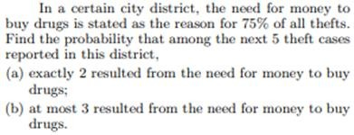
SOLUTION:
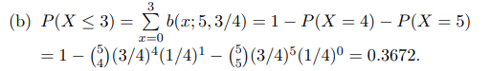
Q2.
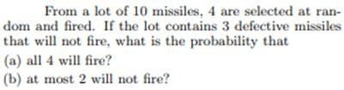
SOLUTION:
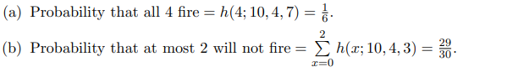

Q3.
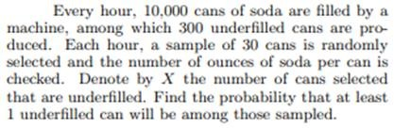

SOLUTION:

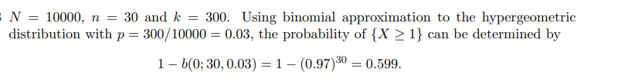

Q4.
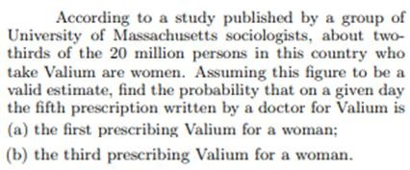
SOLUTION:

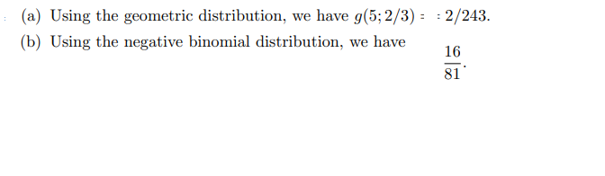

Q5.

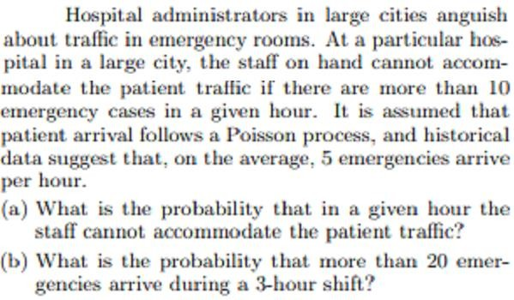

SOLUTION:
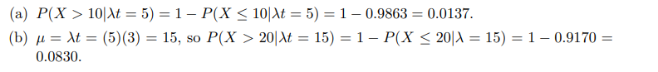
Q6. [CLO-5]
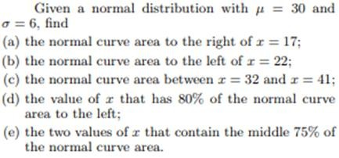
SOLUTION:
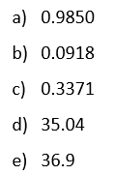

Q7.
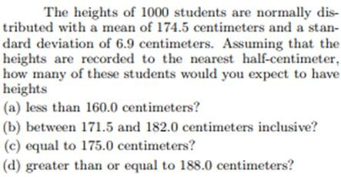
SOLUTION:
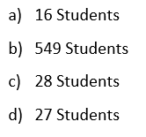
Q8.

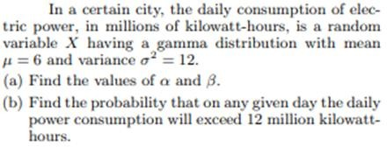

SOLUTION:
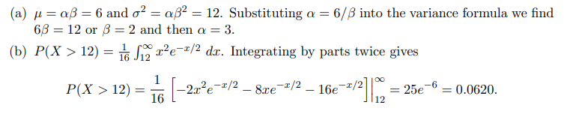

Q9.
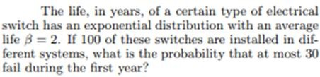
SOLUTION:
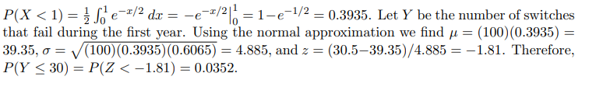
Q10.
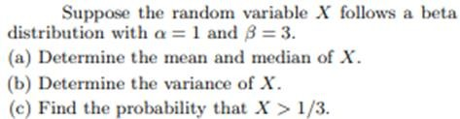
SOLUTION:
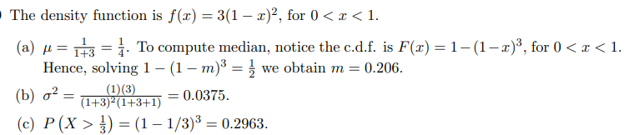

Q11.
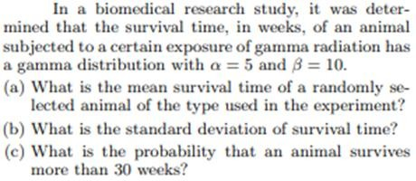
SOLUTION:
